IOT and Healthcare:
Remote Patient Monitoring, Wearable Devices, and Telemedicine

Mr. Danish Solkar
Computer Department
A.I. Abdul Razzak Kalsekar Polytechnic
Panvel, India
E mail : danishsolkar30@gmail.com

1. Introduction :
The Internet of Things (IoT) is transforming healthcare through the integration of connected devices, sensors, and objects. This technological shift is crucial for remote patient monitoring, wearable devices, and telemedicine, which address challenges like escalating healthcare costs, an aging population, and the demand for more accessible, personalized care. This report will provide a comprehensive overview of IoT's role in healthcare, including its architecture, applications, benefits, challenges, future trends, and real-world case studies.

The integration of IoT technologies is particularly crucial in three key areas: remote patient monitoring (RPM), wearable devices, and telemedicine. These technologies are addressing pressing challenges such as rising healthcare costs, an aging global population, and the need for more accessible and personalized care. This report aims to provide a comprehensive overview of the role of IoT in modern healthcare, exploring its architecture, diverse applications, and associated benefits and challenges. The scope includes an analysis of current trends and a look into future opportunities,

Mr. Ayaan Shaikh
Computer Department
A.I. Abdul Razzak Kalsekar Polytechnic
Panvel, India
E mail : ayaan.shaikh1191@gmail.com

supported by real-world case studies to illustrate practical implementation. [1, 2]

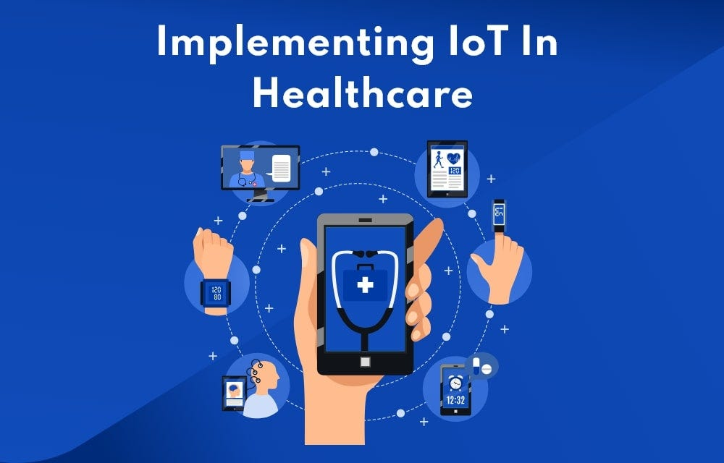
Fig 1.1 IOT in Healthcare

2. IoT Architecture in Healthcare :

The IoT architecture in healthcare is a multi-layered framework designed to collect, process, and transmit data from various medical devices and sensors to a central system. This architecture ensures the reliable and secure flow of information. The basic layers are as follows :-

- Sensing Layer (Perception Layer): The foundational Sensing Layer of IoT in healthcare uses physical devices and sensors to collect data. This includes wearables (e.g., heart rate monitors), implanted devices (e.g., pacemakers), and environmental sensors, which convert physical parameters into digital data.

- Network Layer (Transmission Layer): This layer is responsible for the secure and efficient transmission of data from the sensing devices to the processing and application layers. [3]

A variety of communication technologies are employed, each with specific advantages:

- Bluetooth/Bluetooth Low Energy (BLE):
Ideal for short-range communication between a wearable device and a smartphone or gateway. It is low power and widely available.

- Wi-Fi:
Suitable for connecting devices within a home or hospital network, offering high bandwidth for transmitting large data files like medical images.

- Cellular (4G/5G):
Provides ubiquitous connectivity for remote patient monitoring, especially in areas without Wi-Fi. 5G is a game-changer due to its ultra-low latency, high bandwidth, and massive device connectivity, which is critical for real-time applications like remote surgery.

- Low-Power Wide-Area Network (LPWAN):
Technologies like LoRaWAN and NB-IoT are designed for low-power, long-range communication, making them suitable for devices that need to operate for months or years on a single battery charge, such as asset trackers in a large hospital.

- NFC (Near-Field Communication):
Used for contactless data exchange over very short distances, often for quick device pairing or data transfer from a sensor to a smartphone.

- Data Processing Layer
(Processing Layer):
This layer involves the collection, analysis, and storage of the data received from the network layer. This is where cloud computing and edge computing play a crucial role. [2]

- Cloud Computing:
Provides scalable and robust infrastructure for storing vast amounts of patient data and running complex analytics. Services like AWS, Google Cloud, and Microsoft Azure offer the necessary tools for data storage, machine learning, and application hosting.

- Edge Computing:
Involves processing data closer to the source (i.e., on the device or a local gateway). This is essential for real-time applications where low latency is critical, such as monitoring a patient's vital signs and triggering an immediate alert if a critical threshold is breached. It also reduces network congestion and enhances data privacy by processing sensitive information locally.

- Application Layer:
This is the top layer, where the processed data is presented to end users (patients, doctors, caregivers) through user-friendly interfaces. Examples of applications include mobile health apps, electronic health records (EHR), and telemedicine platforms that enable virtual consultations. [1]

3. Applications of IoT in Healthcare :
The versatility of IoT technology has led to a wide range of applications that are reshaping the healthcare industry.
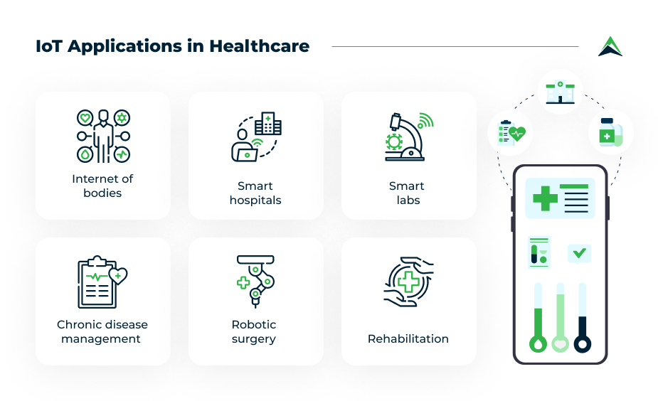
Fig 1.2 Applications of IOT in Healthcare

- Remote Patient Monitoring (RPM):
RPM systems allow healthcare providers to monitor patients outside of clinical settings, reducing the need for frequent hospital visits. They are particularly effective for managing chronic diseases such as diabetes, hypertension, and heart disease. [2]

- Wearable Devices:
Wearables have moved beyond fitness tracking to become powerful diagnostic and monitoring tools.

- Smartwatches and Fitness Trackers:
These devices monitor heart rate, activity levels, and sleep patterns, providing users and doctors with a continuous stream of health data.

- Continuous Glucose Monitors (CGMs):
For diabetic patients, CGMs eliminate the need for frequent finger pricks, providing real-time glucose readings that can be shared with healthcare providers.

- Wearable ECG Monitors:
These devices can detect irregular heart rhythms and atrial fibrillation, helping to identify and manage cardiac conditions early.

- Smart Patches:
Small, adhesive sensors that can continuously monitor vital signs, body temperature, and other metrics, which is especially useful for post-operative care and infant monitoring.

- Hospital Automation:
IoT sensors and devices are optimizing hospital operations.

- Asset Tracking:
RFID tags and BLE beacons are used to track medical equipment (e.g., wheelchairs, infusion pumps), reducing search time and preventing loss.

- Smart Beds:
Equipped with sensors that monitor a patient's position and vitals, these beds can automatically adjust to prevent bedsores and alert nurses to potential issues.

- Medication Dispensing:
IoT-enabled smart cabinets and pill dispensers ensure that patients receive the correct medication at the right time, improving adherence and safety.

4. Benefits of IoT in Healthcare :
The adoption of IoT in healthcare offers a multitude of benefits that impact patients, providers, and the overall healthcare system.
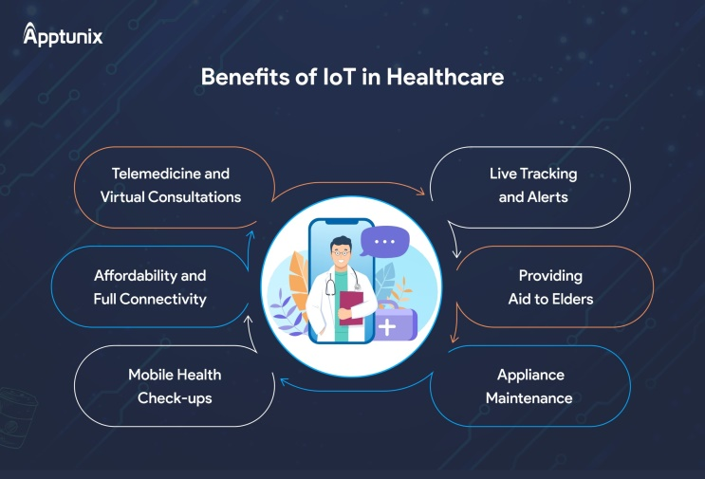
Fig 1.3 Benefits of IOT in Healthcare

- Improved Patient Care and Early Diagnosis:
Continuous, real-time data from IoT devices allows for proactive rather than reactive care. Doctors can detect subtle changes in a patient's health metrics and intervene before a serious condition develops, leading to better outcomes. [1]

- Reduced Hospital Visits and Cost of Healthcare:
By enabling remote monitoring, IoT minimizes the need for non-critical hospital visits, readmissions, and extended stays. This significantly reduces healthcare costs for both patients and providers. [4]

- Better Healthcare Access in Rural/Remote Areas:
Telemedicine and remote monitoring enabled by IoT bridge the geographical gap, allowing patients in remote areas to access high-quality specialist care without traveling long distances.

- Personalized Treatment and Preventive Care:
The vast amount of data collected from wearables and sensors allows healthcare professionals to gain a detailed understanding of an individual's health. This data can be used to create highly personalized treatment plans and to recommend preventive measures tailored to a patient's lifestyle and risk factors. [3]

- Real-time Data for Doctors and Caregivers:
IoT provides an up-to-the-minute view of a patient's health status, enabling doctors and caregivers to make more informed and timely decisions. Alerts can be configured to notify them of any critical changes, ensuring a rapid response to emergencies.

5. Challenges in IoT-enabled Healthcare:
Despite its transformative potential, the widespread adoption of IoT in healthcare faces significant challenges.

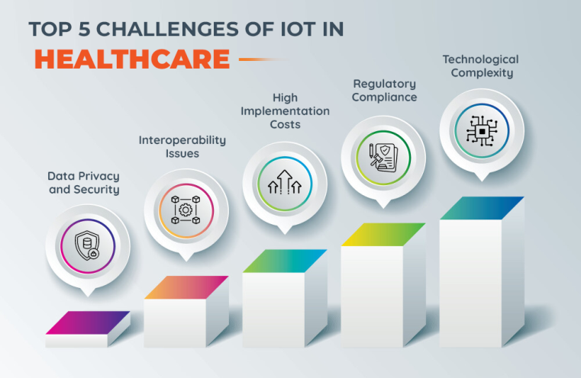
Fig 1.4 Challenges of IOT in Healthcare

- Device Reliability and Battery Life:
Medical IoT devices must be highly reliable and have a long battery life to ensure continuous monitoring, especially for critical conditions.

- Data Management Issues:
The sheer volume and velocity of data generated by IoT devices create a big data challenge. Storing, processing, and analyzing this data in real-time requires sophisticated infrastructure and robust analytics capabilities.

- Interoperability:
A lack of standardized protocols can make it difficult for devices from different manufacturers to communicate with each other and with existing electronic health record (EHR) systems. [5]

- Ethical and Legal Concerns:
Issues such as patient consent for data collection, the ownership of health data, and liability in the case of a device malfunction or data driven misdiagnosis are complex and require clear legal and ethical frameworks.

- Security and Privacy Issues:
Healthcare data is among the most sensitive personal information. IoT devices and networks are vulnerable to cyberattacks, which could lead to data breaches and compromise patient privacy. Ensuring compliance with strict regulations like the Health Insurance Portability and Accountability Act (HIPAA) in the U.S. and the General Data Protection Regulation (GDPR) in Europe is a major hurdle.

- Infrastructure & Cost Barriers:
The initial high implementation cost of IoT systems, including hardware, software, and network infrastructure, can be prohibitive for smaller healthcare facilities.

6. Future Opportunities and Trends :
The future of IoT in healthcare is promising, with several emerging trends poised to further transform the industry.
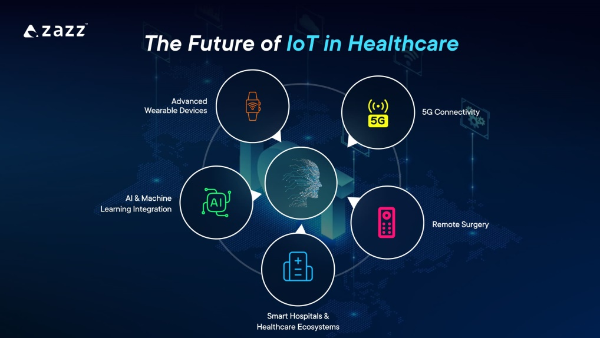
Fig 1.5 Future of IOT in Healthcare

- AI and Machine Learning for Predictive Healthcare Analytics:
AI algorithms can analyse the massive datasets from IoT devices to identify patterns and predict health events before they occur. This will enable predictive healthcare, where doctors can intervene proactively to prevent diseases. [1]

- Blockchain for Secure Medical Data Sharing:
Blockchain technology can create a decentralized, immutable ledger for medical data, ensuring secure and transparent sharing among patients, providers, and researchers. This can enhance data security and patient control over their health records.
- Integration of 6G Networks:
As 6G networks are developed, their ultra-fast speeds and zero latency will enable even more advanced applications.

- Smart Implants and Biosensors:
The next generation of medical devices will include even more sophisticated implantable sensors and biosensors that can monitor everything from organ function to drug levels in the bloodstream, providing continuous internal health data.

- Digital Twins of Patients:
A digital twin is a virtual replica of a patient, created from real-time data collected from various sensors and devices. This allows doctors to simulate different treatment plans on the digital twin to determine the most effective approach for the patient, leading to highly personalized medicine. [4]

- Expansion of Global Telemedicine Platforms:
The success of telemedicine during the pandemic is driving the expansion of platforms that can provide remote care on a global scale, bridging geographical divides and democratizing access to healthcare.

7. Case Studies / Real-World Examples

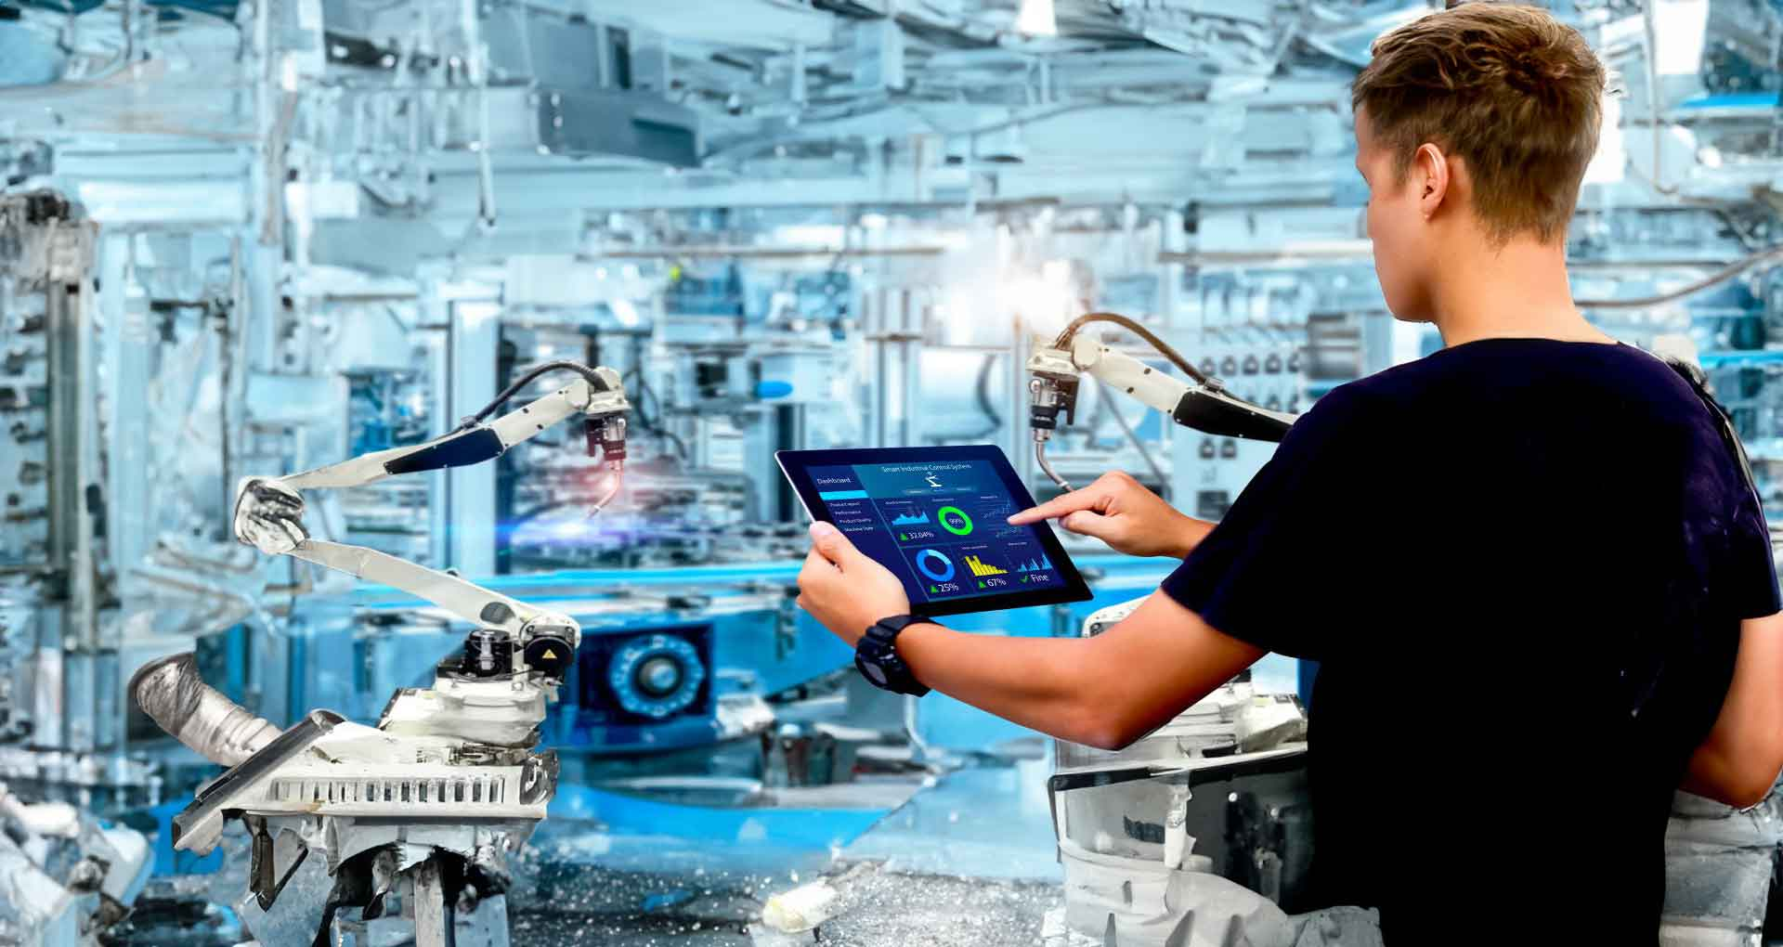
Fig 1.6 IOT in Healthcare Use cases
- Smart Hospitals:
The Apollo Hospitals group in India and the Mayo Clinic in the U.S. are examples of smart hospitals. They use IoT for various applications, including asset tracking, smart patient monitoring in intensive care units, and automated medication dispensing systems, leading to improved operational efficiency and patient safety.

- Use of Wearables in Managing Diabetes and Cardiac Patients:
Companies like Dexcom and Abbott produce Continuous Glucose Monitors (CGMs) that transmit real-time glucose data to a smartphone or a wearable device. This data can be shared with a doctor, who can remotely adjust insulin doses or provide dietary advice. Similarly, devices like the AliveCor KardiaMobile allow cardiac patients to take a medical-grade ECG at home and share it instantly with their cardiologist, enabling quick diagnosis of heart rhythm abnormalities.

- IoT-driven Telemedicine Projects in Rural Healthcare:
In countries like India and several African nations, organizations and governments are using IoT to establish telemedicine hubs in remote villages. These centers are equipped with basic diagnostic tools (e.g., digital stethoscopes, otoscopes) that are connected to the internet. A local healthcare worker can use these devices to collect patient data, which is then transmitted to a specialist in a city who can provide a diagnosis and prescription. This has significantly improved healthcare access and reduced travel time and costs for patients. [3]

8. Conclusion
IoT is transforming healthcare into a connected, efficient, and patient-focused system. Remote monitoring, wearables, and telemedicine improve outcomes, lower costs, and increase access. Despite challenges in security, interoperability, and ethics, innovations such as AI, blockchain, and 6G promise a future of preventive, personalized, and predictive care.

Healthcare providers should invest in secure, scalable IoT systems, while policymakers develop clear privacy and ethical regulations. Researchers must advance interoperability and next-generation biosensors. Collaboration among technologists, clinicians, and regulators is key to realizing IoT’s full potential for better healthcare.

9. References
[1] S. Kumar et al., “IoT in Healthcare: Architecture, Applications, and Security Issues”
Accessed : 14 Sept 2025.
[2] P. Gupta and R. Sharma, “Remote Patient Monitoring using IoT”
Accessed : 15 Sept 2025.
[3] A. Smith, “Telemedicine and Wearables in Healthcare Transformation”
Accessed : 15 Sept 2025.
[4] L. Chen and H. Li, "The Role of IoT in Personalized and Predictive Healthcare"
Accessed : 16 Sept 2025.

[5] R. Singh and V. Kumar, "Challenges and Future Prospects of IoT in Healthcare: A Comprehensive Review"
Accessed : 16 Sept 2025.
[6] J. Patel, "Data Management and Security in IoT-Enabled Healthcare Systems"
Accessed : 16 Sept 2025.

